**Al-Zaytoonah University of Jordan**

**Faculty of Science and Information Technology**



**Project Title**

E-ecommerce food Truck

**By: Students’ Name**

M**ohannad e**ss**am abubaker**

Rashed Abdullah hunitie

Basil Ramzi issa

**Supervisor:**

**Dr. Kholoud Abu Marai**

***Submitted in partial fulfillment of the requirements for the degree of Bachelor of Computer Information System***

***2021-2022***

**Project Team**

**Project Manager:**

**Student Name:** Mohannadessamabubaker

**Profile:**

**(Who is? Personal Skills :** leader, communication skills

**, Technical Skills:** Backendprogramming**,** Database**, , …, and Role)**

**Project Member 1:**

**Student Name:** RashedHunitie

**Profile:**

**(Personal Skills :**Active listening and flexible,

**Technical Skills:**  Database **,**

**…, and Role)**

**Project Member 2:**

**Student Name:** Basilissa

**Profile:**

**( Personal Skills:** motivator, working on time , Technical Skills: frontend**, …, and Role)**

***Note: This page is optional***

**ACKNOWLEDGEMENTS**

|  |  |
| --- | --- |
| **Table of Contents**  **Abstract..............................................................................................................................................2**  **‎Acknowledgment..................................................................................................................3**  **‎List of Figures....................................................................................................................................6**  **List of Tables.....................................................................................................................................7**  **Chapter One …………………........................................................................................................8**  **1.1 Introduction …………………………………………………………………………………….9**  **1.2 Background................................................................................................................................10**   * **Business Model ........................................................................................................................10**   **1.3.1 Problem Definition...........................................................................................................10**  **1.3.2 Proposed System..............................................................................................................10**  **1.3.3 Project Scope…................................................................................................................11**  **1.3.4 Objectives.........................................................................................................................11**  **1.3.5 System Capabilities …………………………………………………………………….11**  **1.3.5 Motivations.......................................................................................................................11**  **1.3.6 Stakeholders Analysis.......................................................................................................12**  **1.4 Environment..............................................................................................................................13**  **1.5 Project Management..................................................................................................................14**  **1.5.1 Project Schedule.....................................................................................................................14**  **1.5.2 Project Risk.............................................................................................................................14**  **1.5.1 Project Schedule.....................................................................................................................14**  **1.6 Summary....................................................................................................................................16**  **Chapter Two: Systems Planning and Analysis Phase....................................................................17**  **2.1 Introduction...............................................................................................................................18**  **2.2 Planning Phase..........................................................................................................................18**  **2.3 Analysis Phase...........................................................................................................................19**  **2.4 Information Gather Techniques ………………………………………………………………19**  **2.4.1 Interview ……………………………………………………………………………….20**  **2.4.2 Observation …………………………………………………………………………….21**  **2.4.3 Sampling ……………………………………………………………………………….22**  **2.5 System Requirements Specifications ………………………………………………………....23**  **2.5.1 Functional Requirements.................................................................................................24**  **2.3.2 Non- Functional Requirements........................................................................................25**  **2.6 Summary....................................................................................................................................26**  **Chapter Three: System Design Phase…………...........................................................................27**  **3.1 Introduction...............................................................................................................................27**  **3.2 Design Phase.............................................................................................................................28**  **3.2.1 Data Flow Diagram.................................................................................................................29**  **3.2.1.1 DFD Context Diagram...............................................................................................30**  **3.2.1.2 DFD 0 Diagram.........................................................................................................31**  **3.2.1.3 Child DFD Diagrams.................................................................................................32**  **3.3 Summary ………………………………………………………………………………………3** | |
|  | |
|  |  |

**LIST OF TABLES**

**Page**

|  |  |  |
| --- | --- | --- |
| **2.1** | **{Table Name}** | **26** |
| **2.2** | **…….** | **40** |
|  |  |  |

**LIST OF FIGURES**

**Page**

|  |  |  |
| --- | --- | --- |
| **1.1** | **{Figure Name}** | **2** |
| **1.2** | **….** | **3** |

**{Project Title}**

**ABSTRAC**

a website application where users can sign up with their contract information and their address, So they can start with the ordering process.

They get to choose they food type, quantity and time of the event, and then they can proceed with the purchasing process.

Using agile methodology project management, that helps to distribute the tasks among the team members to give a comprehensive approach of the project.

We used Visual Studio and PHP My Admin as the main platforms to write and build the system of the website.

Working through this project, we were able implement many programming techniques, and improve our programming skills as well.

**………………………………………..**

**……………**

**…………….**

**LIST OF ABBREVIATIONS AND TERMINOLOGIES**

|  |  |
| --- | --- |
| **AES** | **: Advanced Encryption Standard** |
| **Alice** | **: The name traditionally used for the first user of cryptography in a system; Bob's friend** |
| **ANSI** | **: American National Standards Institute** |

**….**

**…**

**…**

**Chapter 1: Introduction**

* **Introduction**

Food trucks, the same image comes to everyone's mind when hear this phrase. A truck with a fixed location where people go to, to order from a limited menu.

But in this project we will change this image to a more contemporary and practical project.

A mobile food truck, that is fully equipped that servers a plethora of dishes and meals, with a website where people can book the food truck for wedding, birthdays and other special events.

* **Background**

In this project, we will work on an application to provide food truck to customers. Helping them meet their needs by reserving a truck and choose what type of food they want.

* **Business Model**
* **Problem Definition (Statement)**

The main problem is adherence to specific locations and the inability to move around, because there is no location for the truck owner. And there is no platform to support these projects

* **Proposed System (Vision System)**

Customer updates about recent items in the food truck.

The program enables the Truck Owner to add new products to the site.

develop website online by helping citizens meet all their needs with the continuity.

* **Project Scope**

The application is an E-commerce business. the user can select food truck and the type of food that he needs for his occasion that he needs through the application, and then Click to end the purchasing process, then add the address.

And the targeted people Citizens who have public or private occasion.

* **Project Purpose (Objectives)**

1-Enable the costumer to order from his home.

2- cutting coast because in the business doesn’t need to rent a restaurant and less employees.

3- Saving time and effort.

4-Continuing work and development until after graduation and applying it on the ground to become a real market and return to us with financial returns.

* **Motivations**

-Meaningful work.

-Shared responsibilities.

-Business impact.

* **Stakeholder Analysis**

|  |  |
| --- | --- |
| **Role in Project** | **Stakeholder Name** |
| -Can(login and logout)account.  -Can(Acceptance, delete, add) Truck Owner. | **-Admin** |
| -Can(Search)Truck Owner  -Can(login and logout)account.  -Can (buy)pre order truck. | **-User** |
| -Can(add, delete)meals.  -Can(login and logout) account.  -Can(Acceptance, delete)order  -Can(add menu) | **Truck Owner** |

* **Environment**
* **Tools Needed (Used)**

Software name: visual studio.

Programming language : php.

Database: xampp-php myadmin.

Project Management: Microsoft project management.

Design: visual paradigm.

* **Hardware Specification**

Local host.

* **Project Management**

Project management is the process of leading the work of a team to achieve goals and meet success criteria at a specified time. The primary challenge of project management is to achieve all of the project goals within the given constraints

* **Project iteration schedule (Gant chart)**

This project will take one and half month to implement.

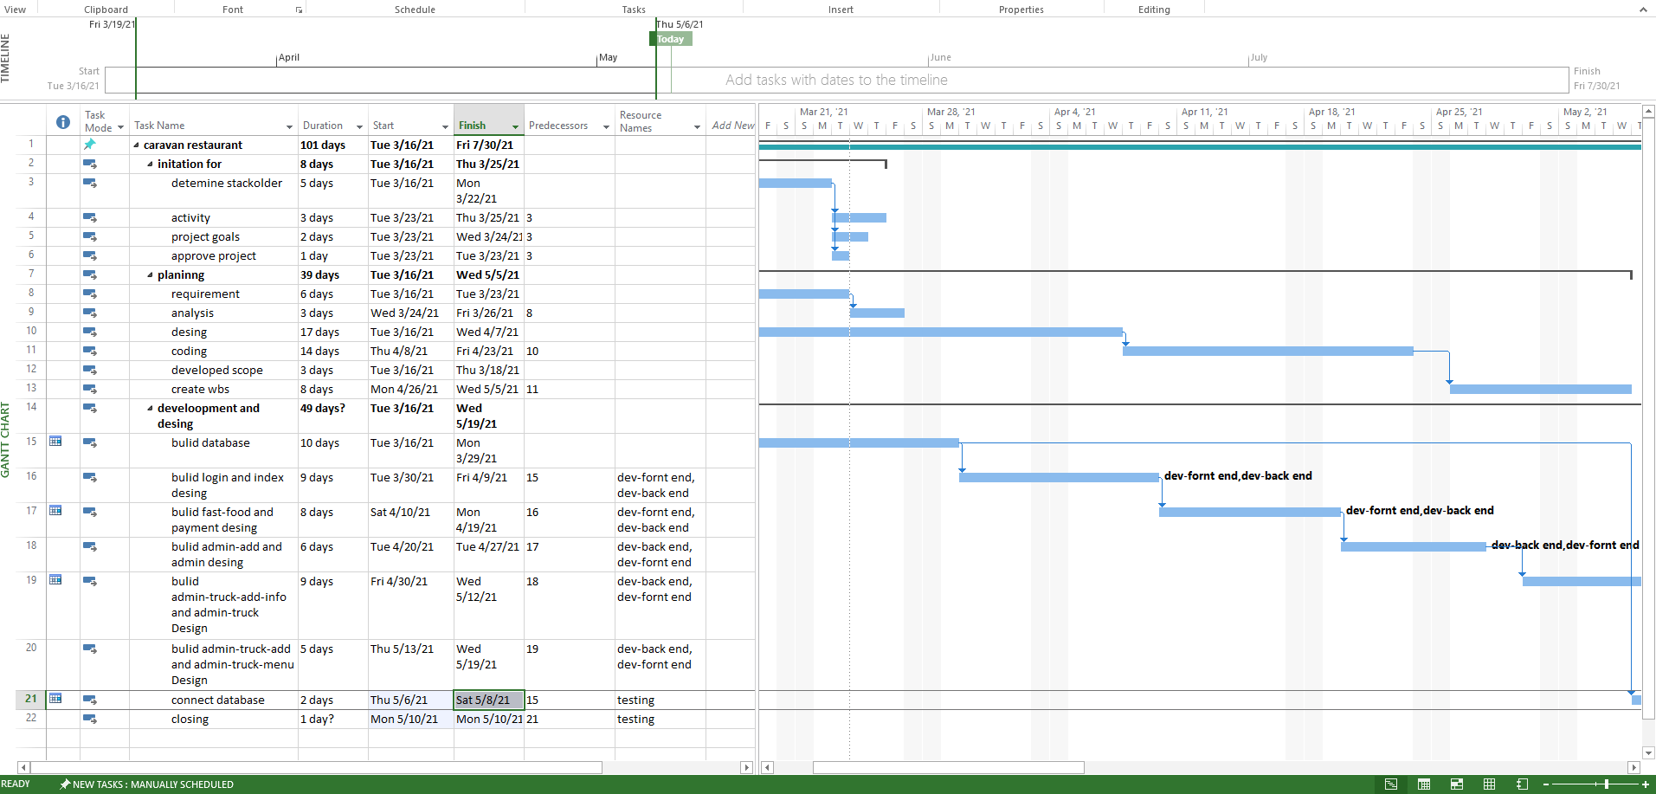

**Figure 1:Project Gant Chart**

* **Project Risks and Feasibility**
* Leave some fields blank on payment »» User must fill in all fields
* Leave some fields blank on Truck Owner »» truck Admin must fill in all fields
* we cant specify the location automatically
* admin Only he can see which requests have been approved And truck food that you want to join
* **Summary**

In this chapter, writing about the basic idea of the project, which was summarized in solving the problem of people who want to meet all their needs through one website.

Specify scope, objectives, motivations, stakeholder analysis, the software used, and the risk for this project.

**Chapter 2**

**System Planning and Analysis Phases**

**2.1 Introduction**

The system analysis process was done using the SDLC system development life cycle method, as this method consists of 7 steps:

**2.2 Planning Phase or Inception Phase:**

1. identify the problems that led to the design of the system; The goals of the system; Opportunities that the system can offer to the user.

2. Determine the system requirements for information.

3. System needs analysis, analysis of the information gathered, and analysis of the rest of the needs.

4. System design, starting with the actual design from designing for screens and databases.

5. Software development and documentation.

6. Begin testing and modifying the system if needed.

7. System evaluation and application.

**2.3 Analysis Phase**

The Analysis Phase is where multiple collected and processed items are examined, correlated, and given the necessary context the make them useful.

**Agile methodology (Incremental model )**

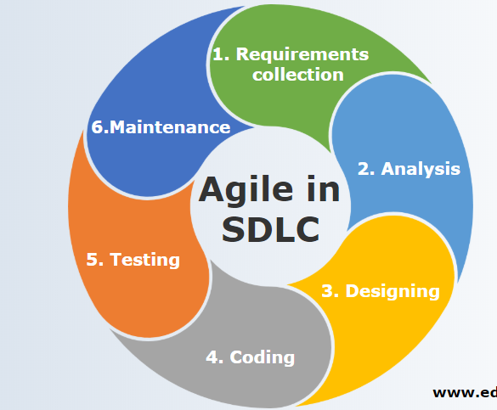

**Figure 2: Agile**

**2.5 Information Gather Techniques**

There are many techniques that can be employed when gathering information. The type of information you are trying to obtain, as well as the people providing the information, will determine which techniques you should use.

**Traditional Methods of Gathering Information**

Traditional methods of gathering information include:

* Interviews
* Questioning
* Questionnaires
* Observation
* Study of existing organizational documents, forms and reports

**2.5.1 Interview**

Interview with Caravan Burger Makers, gathering information and finding out about problems

**2.6 Software Requirement Specification (SRS)**

detailed description of a software system to be developed with its functional and non-functional requirements. The SRS is developed based the agreement between customer and contractors. It may include the use cases of how user is going to interact with software system.

**2.6.1 Functional Requirements**

|  |  |  |
| --- | --- | --- |
| **Stakeholder** | **Role** |  |
| **1)Administrator** | Login  Logout  Add Account truck | See what requests have been accepted  Caravan requests to join |
| **2) User** | Login  Logout  SignUp | Search for a Truck  Make order |
| **3) Truck Owner** | Login  Logout  SignUp | Confirm order  Create a menu  Delete order  Add new meal  Delete meal |

**2.6.2 Non- Functional Requirements**

**Performance :**

* Any interaction between the user and the websit not to exceed 15 seconds.
* The websit available for use 24 hours per day.

**Portability and compatibility:**

* It is available on all software and browsers.
* The website runs on, laptops.

**Usability:**

* User-friendly and smooth website

**2.7 Summary**

In this chapter we write how we use Agile methodology project management to divide tasks among team members and what we use approach to understand software processes, explain functional requirements and non-functional requirements.

**Chapter 3**

**System Design Phases**

**3.1 Introduction**

This chapter contains the main issues used in the design process.

It also contains definitions of the important things used in it.

**3.2 Design Phase**

The list of requirements that is developed in the definition phase can be used to make design choices. In the design phase, one or more designs are developed, with which the project result can apparently be achieved. Depending on the subject of the project, the products of the design phase can include dioramas, sketches, flow charts, site trees, HTML screen designs, prototypes, photo impressions and UML schemas. The project supervisors use these designs to choose the definitive design that will be produced in the project. This is followed by the development phase. As in the definition phase, once the design has been chosen, it cannot be changed in a later stage of the project.

**3.2.1 Use Case**

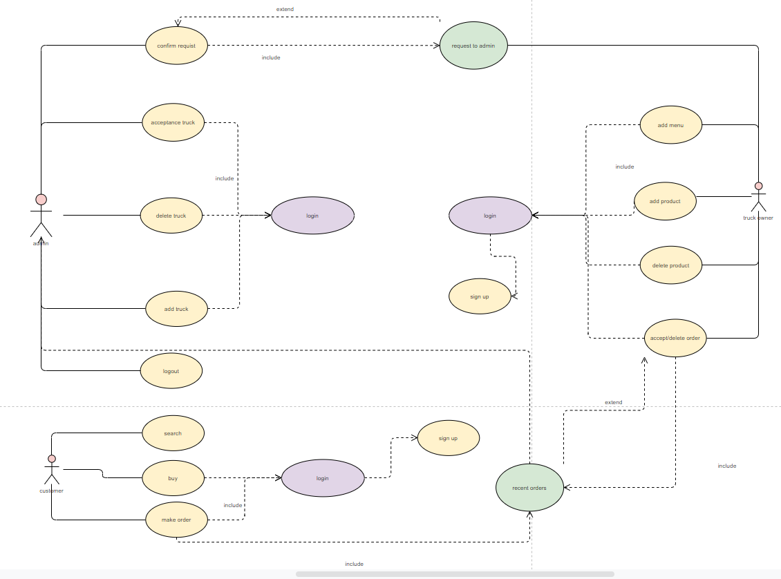

**Figure 3: Use Case**

**3.2.2 Database Design**

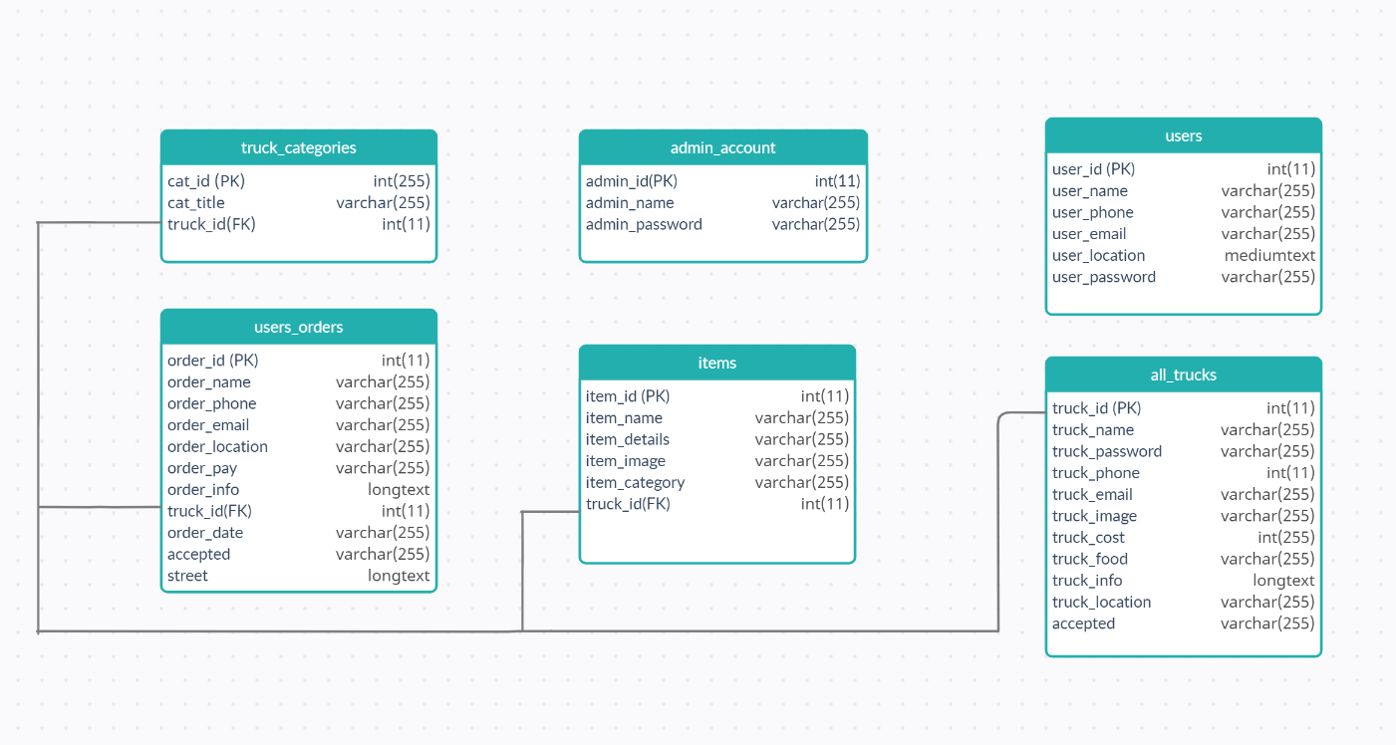

**Figure 4:Database design**

**3.2.3 Screen**

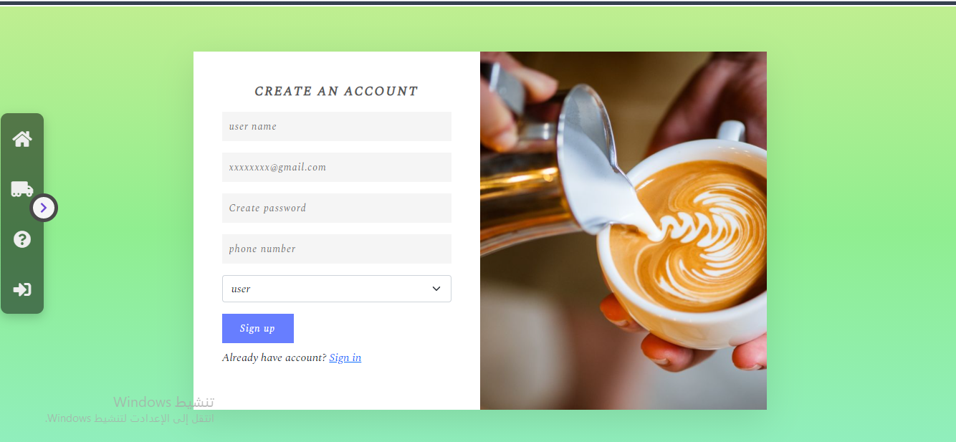

**Figure 5:Sign up page**

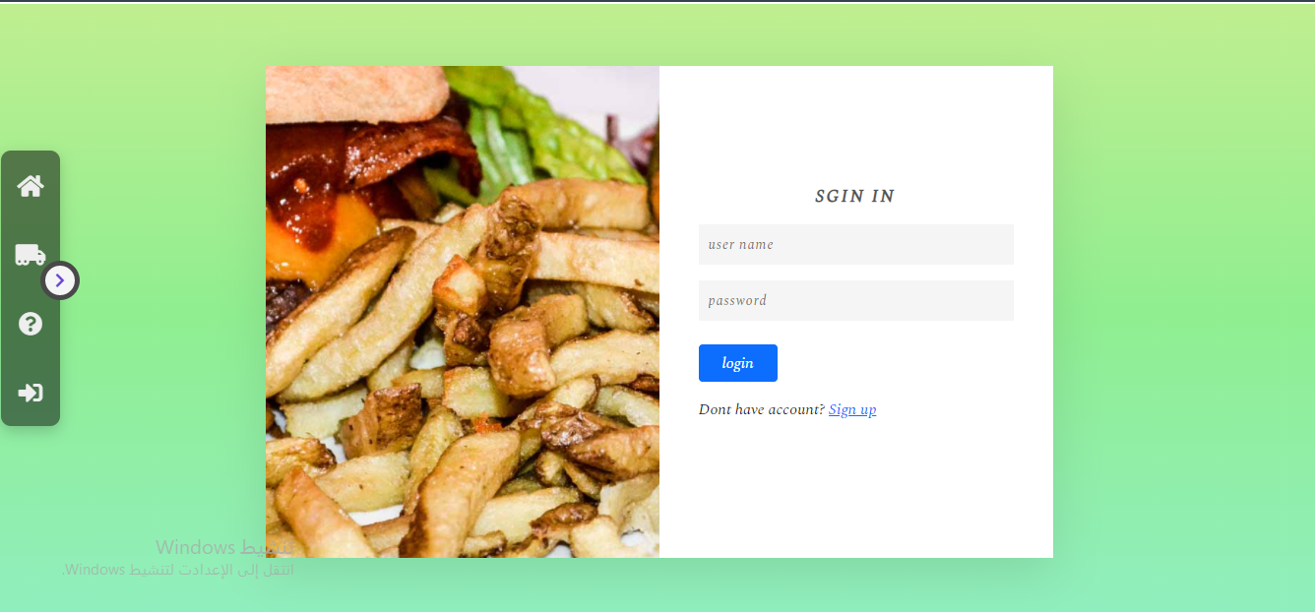

**Figure 6: Login**

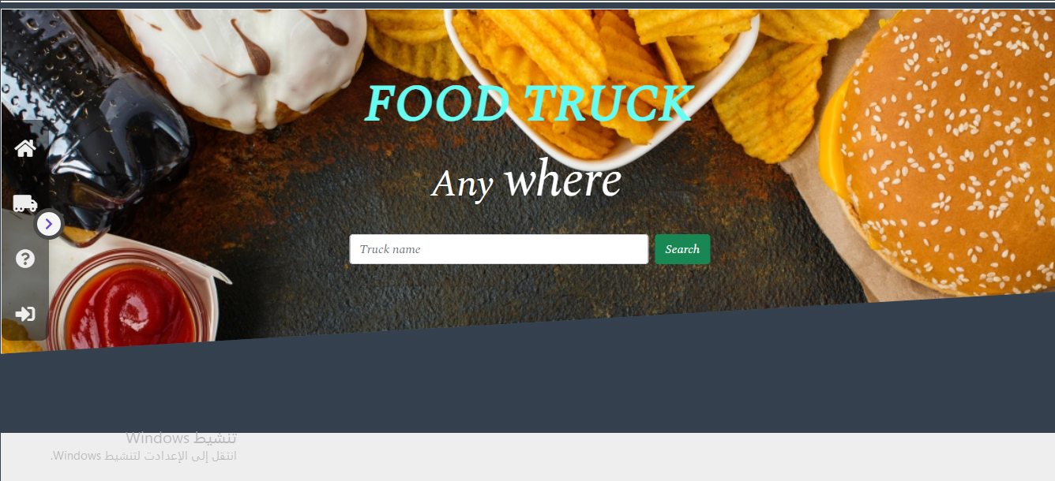

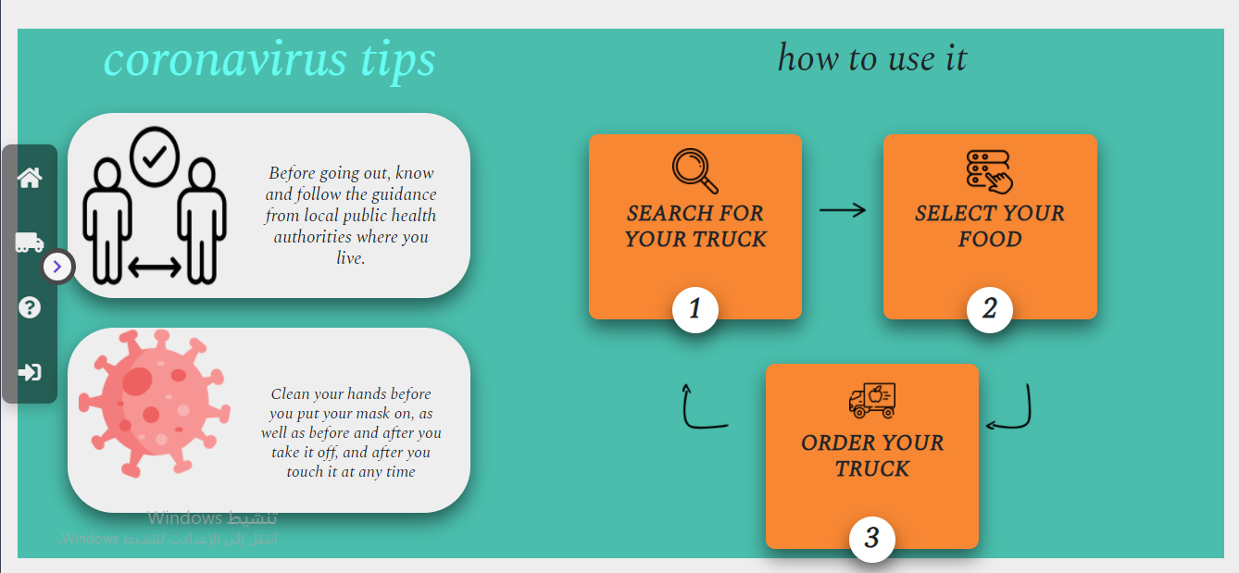

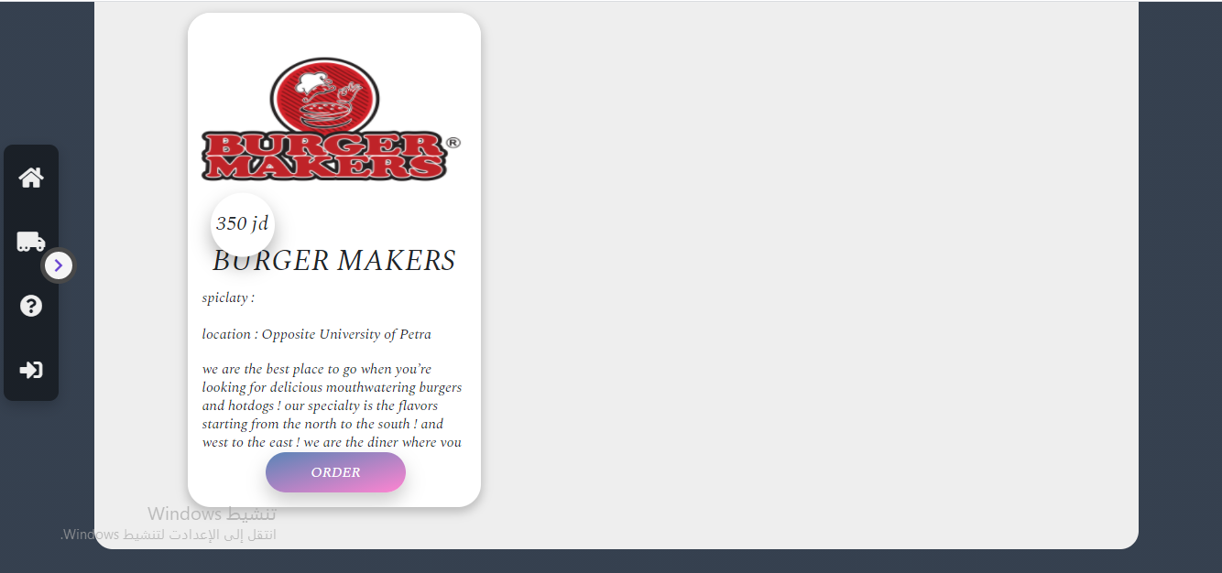

**Figure 7:Home page**

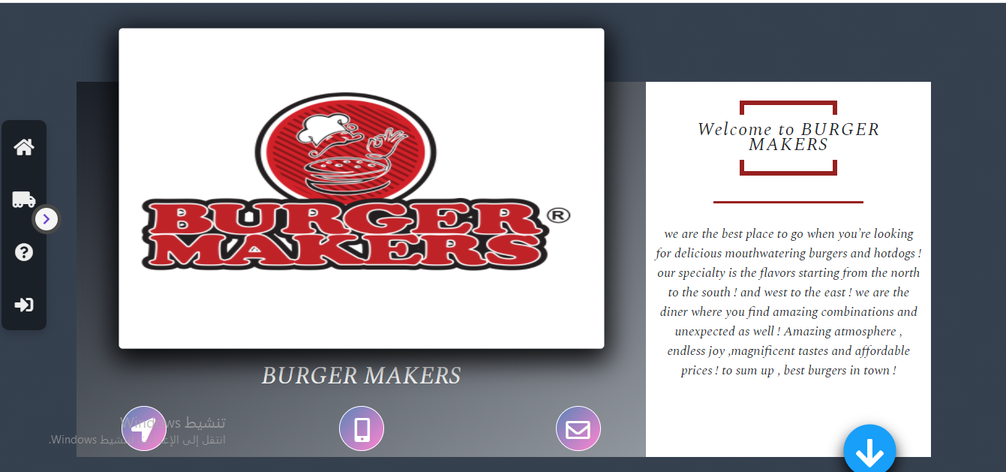

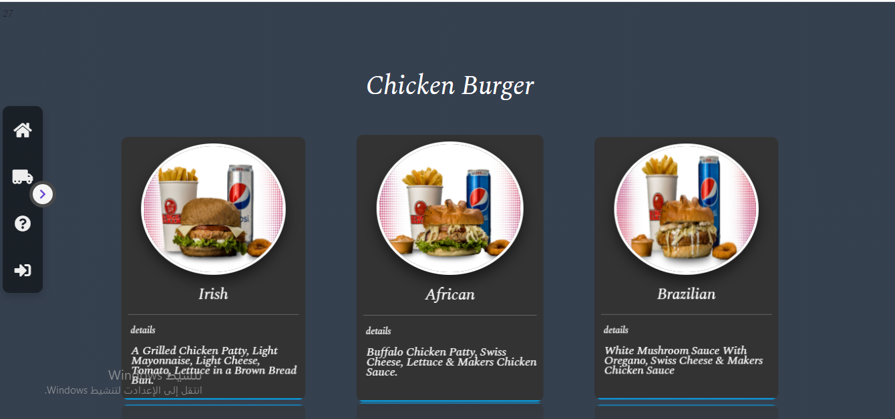

**Figure 8:Menu**

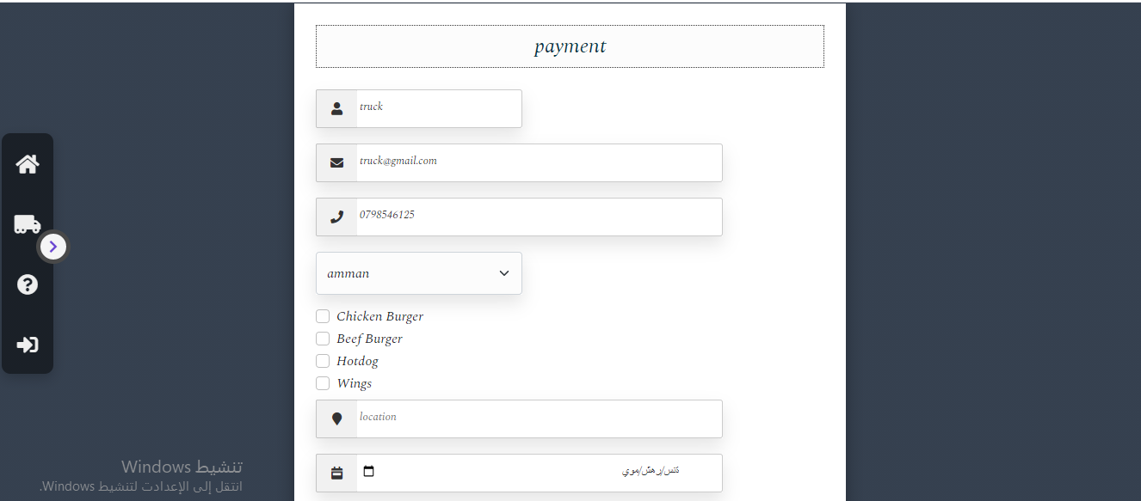

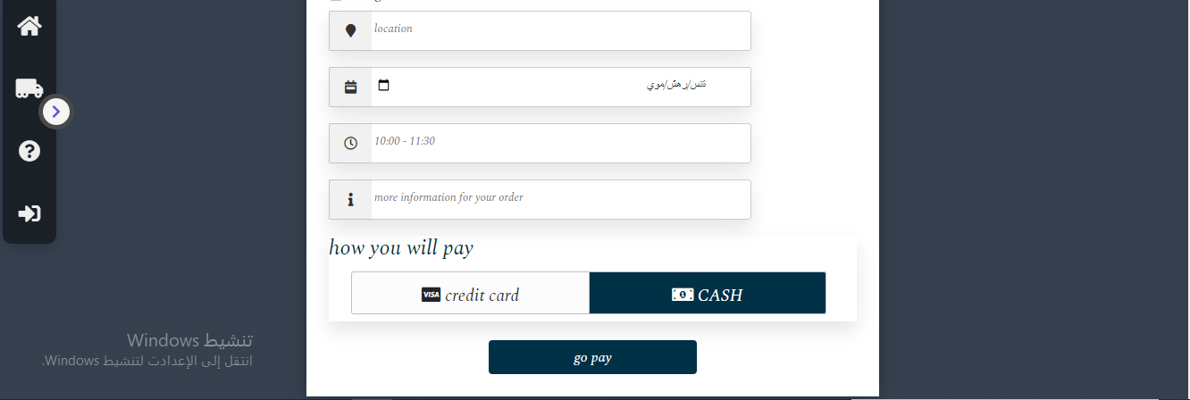

**Figure 9:Payment page**

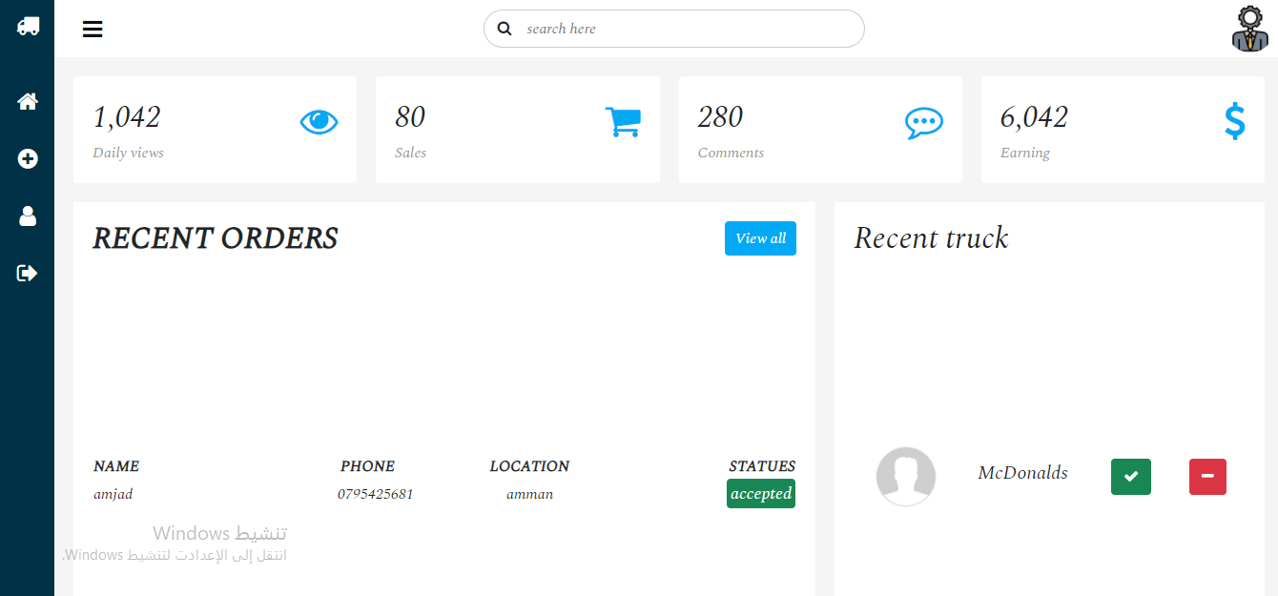

**Figure 10: Admin page**

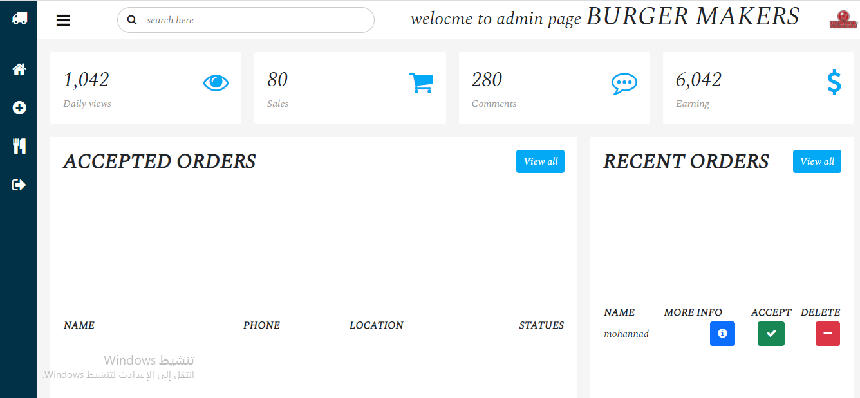

**Figure 11:Truck owner page**

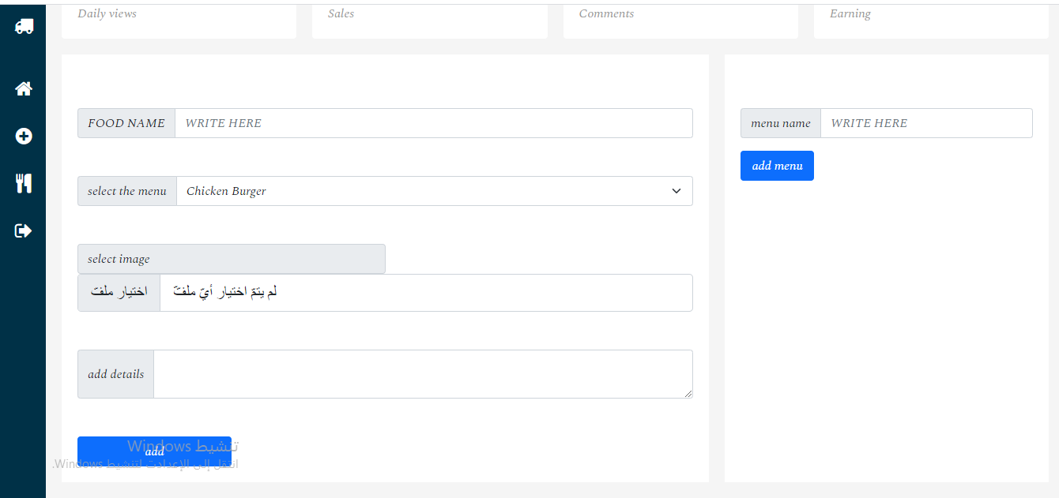

**Figure 12:Truck owner 2 page(add menu, add meals)**

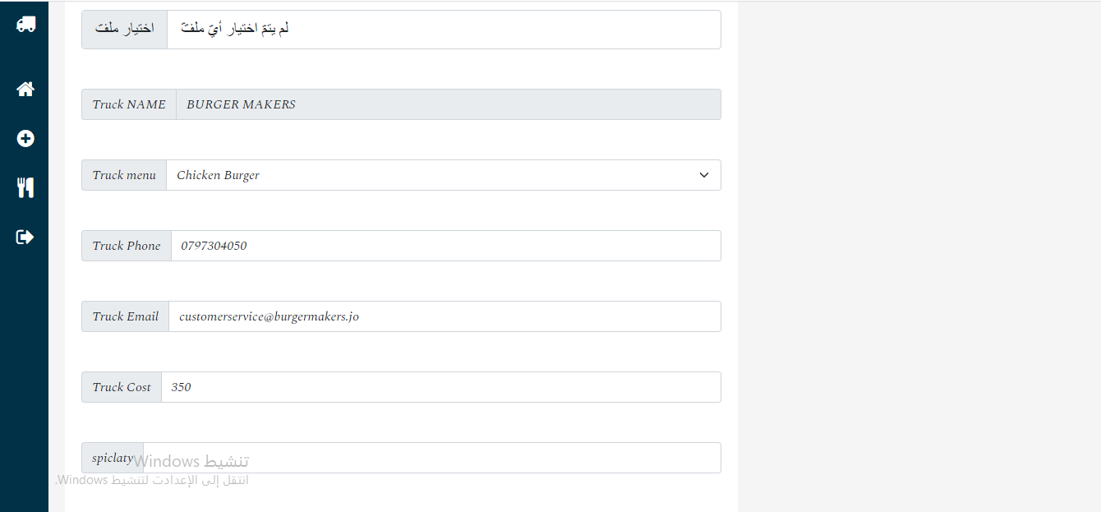

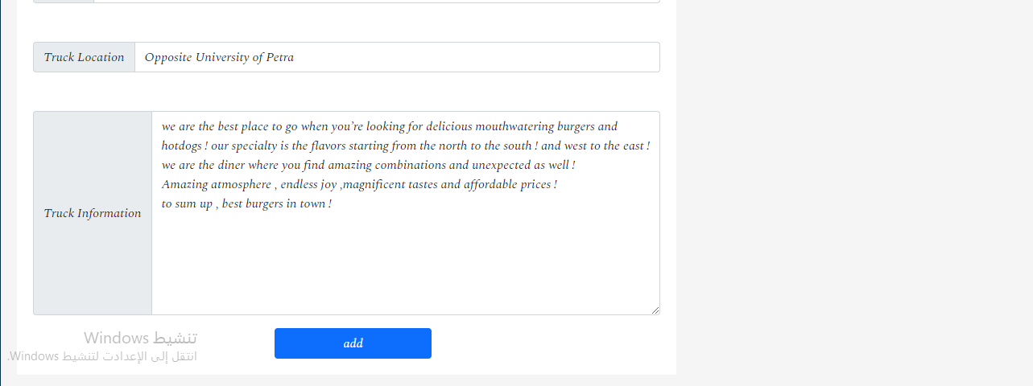

**Figure 13: Truck owner 3 page**

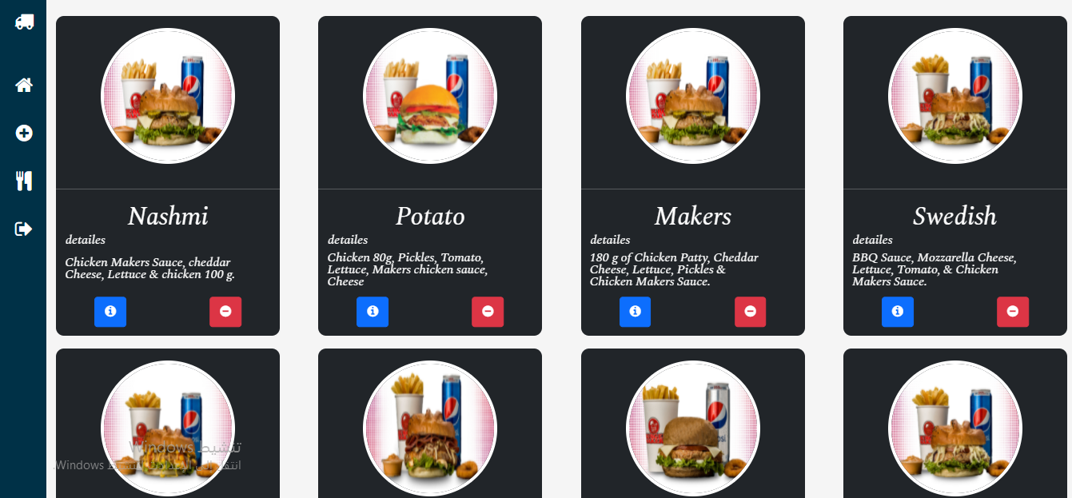

**Figure 14: Meals delete**

3**.4 DFD Diagram**

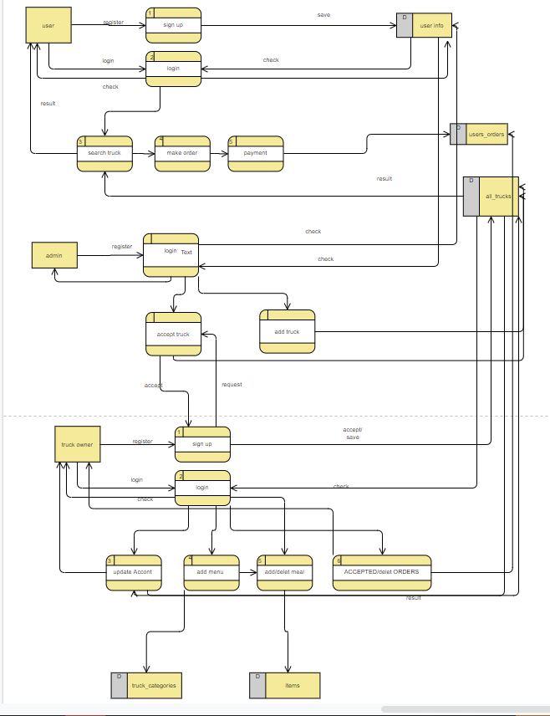

**3.5 Summary**

In this chapter we write what platform we use to build the system and different checklist website to measure software quality

**Chapter 4**

**Conclusion and Future Work**

**4.1 Introduction**

The title of our project is about (Food Truck), and we hope that we will fulfill it.

We are working to deliver comfort and ease to employers and customers.

That is why we are working to include all vehicle owners in one site to improve their work and facilitate access to them by customers.

We also hope that it includes all the important aspects of it, and that no information has been neglected.

**4.2 Conclusion**

The development of this website has been an important stage in our career. We learned a lot of programming techniques that they learned as well as things that we did not deal with before, and we applied many of the things that we learned in the curricula that we studied during the years of schooling.

The graduation project is the starting point in practical life, and we have done what we can to produce it in the best way.

**4.3 Future Work**

After we have reached this stage of the site, we strive to provide people and

vehicle's owners with ease in their lives, and we seek to include all truck owners in one location and facilitate their work in proportion to the owners of food trucks

And facilitate access to them wherever they are to customers

**References**

**[1]** [**https://en.wikipedia.org/wiki/Project_management**](https://en.wikipedia.org/wiki/Project_management)

**[2]https://www.dlsweb.rmit.edu.au/Toolbox/knowmang/content/gathering_data/information_gathering_methods.htm**

**[3]https://www.softwaretestingclass.com/software-requirement-specification-srs/**

**[4]**[**https://www.projectmanagement-training.net/design-phase/**](https://www.projectmanagement-training.net/design-phase/)

**APPENDICES**

**Appendix A**

**Code**

**Appendix B**

**Use Case Figures**

**Appendix c**

**System Screens**

**Appendix d**

**System Reports**

**S**